User Guide

jWebSocket
Representation of data in real time through graphics using jWebsocket framework.
<1.0>

Versioning Control
Date | Version | Description | Author
<12/02/2012> | 1.0 | Preparing the document. | Merly López Barroso

1. Features of the solution
Charting Demo is an application that plots real-time data. Allows users to view the behavior of machine resources, server and users accessing the application. The benefits provided to users are that they can analyze and understand the information that is represented in a more efficient way, increasing customer confidence and credibility to the product. You get a higher level of knowledge and raise the vision and scope that has the information itself.
Charting Demo is an application made by WebSocket communication protocol, which provides graph is achieved in real time the information needed to high levels of speed and scalability.
jWebSocket is the framework in which the application was developed, showing the potential it offers to represent data graphically in real-time web.
The scalability of the servers’ connections supported by jWebSocket allows high user concurrency. Stress tests performed to a jWebSocket server as a result throw 10 000 concurrent connections without affecting the response time of the application. This element ensures not only perform real-time process but to ensure a high number of users using the same service at the same instant of time, which means that 10 000 people around the world can access the application Charting Demo.
2. Main Features
Charting Demo application developed with jWebSocket framework provides the following functionality:
1. Graph Cpu usage.
2. Graph memory usage.
3. Graph swap usage.
4. Graph free hard disk space.
5. Graph space hard disk usage.
6. Graph exchanges per hour.
7. Graph exchanges for days.
8. Graph exchanges for months.
9. Graph users connected.
10. Graph plugins in use.

Charting Demo can be used in most sectors of society. It is fundamental to decision making quick and efficient, this represents a great advantage in the market because it allows to know your stats in real time, and make important decisions from them, offering the possibility to analyze how they develop the other market competitors. It may be helpful to investors and businessmen to keep track of your investments and financial statements. Charting Demo will provide great help to give lectures that require showing the evolution of certain information. Internet businesses play a major role, because nowadays everything moves around the Web. Online virtual stores, stock tickers, user control, resource control of Internet servers that provide services, are some of the ways in which the more you can use this demo.
3. Problems to be solved
Problem | Contributions of the solution
Data traffic or bandwidth in the process of graphical representation on the Web. | Charting Demo is a graphical application which by WebSocket protocol greatly reduces the data traffic of the application.
Latency in the graphical representation process on the Web. | Charting Demo is a Web application that enables you to make the graphical representation process in real-time through the WebSocket protocol.
4. Glossary
Graphical representation: representation of data, usually numeric, using visual aids (lines, vectors, surfaces or symbols) to visually manifest their relationship to each other.
Real Time Web: It is possible when the client receives messages from the server without prior request and end users receive updates simultaneously.
WebSocket: A technology that provides a bidirectional communication channel and full-duplex over a single TCP socket. This protocol solves the limitations of HTTP, by establishing a full-duplex communication (TCP) between the client and server, replacing the half-duplex communication (HTTP). Is reduced, in large proportions, the network traffic when establish WebSocket communication between the client and the server there is only a sending of 2 bits, eliminating the HTTP headers.
JWebSocket framework: a new technology aimed at developing WebSockets based applications that provide high levels of speed, scalability, security and real-time work, a key element for the graphic representation of data today.
Full-Duplex: Quality of the elements that allow the input and output simultaneously.
Half-Duplex: It means that the method or protocol for transmission of information is bidirectional but not simultaneously.

5. Model of the solution
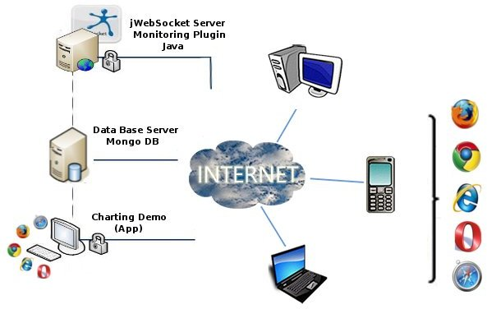

To access Charting Demo the client must use a browser that supports WebSocket protocol. As you connect to the application will begin to graph the behavior of machine resources. You must then select the rest of the information you want to graph and provides the application. Every action that the user makes will be sent to the server jWebSocket, which is responsible for storing in the database server.

7. Requirements for Use
To use the application Charting Demo must have Internet access and use any of the browsers that support the communication protocol WebSocket. Some of them are Google Chrome 4, Safari 5, Mozilla Firefox 8, Opera 11 and Internet Explorer 10.

8. Roles of the solution
Application User: access to all functionality provided by the system and interacts with it.
- System Functioning
Initial view: to access the application begins to graph one of the features provided by Charting Demo.
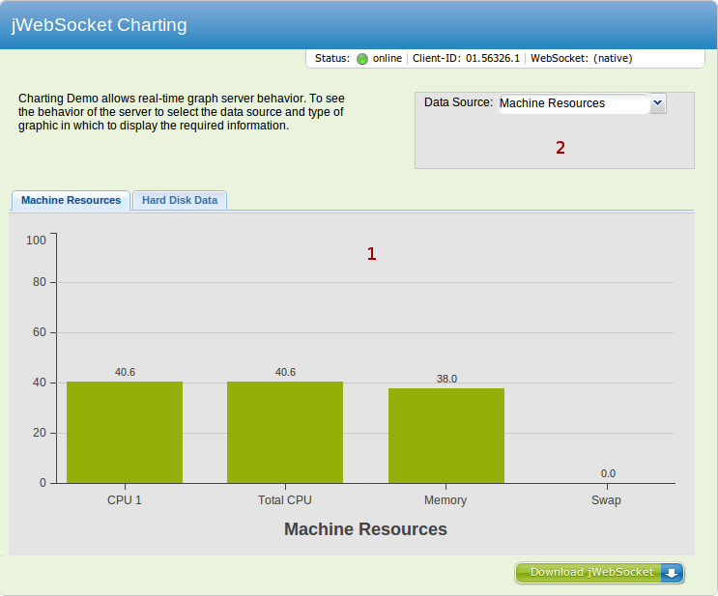

1----- Area where plotted the resources of the machine as cpu, memory, swap.

2----- Area where you select the items you want to graph.
------ Download the framework jWebScocket.

Graphing Using the Hard Drive: when you access the second tab will begin to graph the hard disk usage offered by Charting Demo.
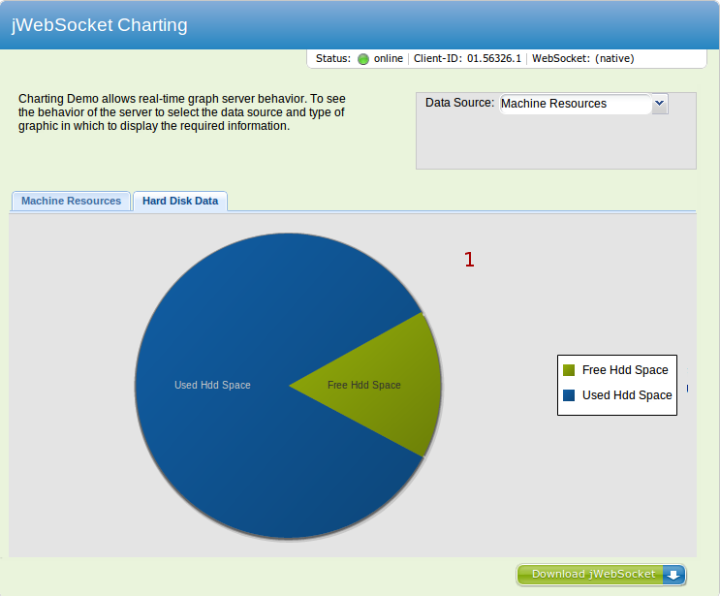
1----- Area where plotted the resources of the machine as hard disk free space and used space on your hard disk.

------ Download the framework jWebScocket.

Graph Number of exchanges per server per hour: access to the combobox option which allows representing hourly exchanges made ​​to the server and selects a desired day to see the behavior of that day.
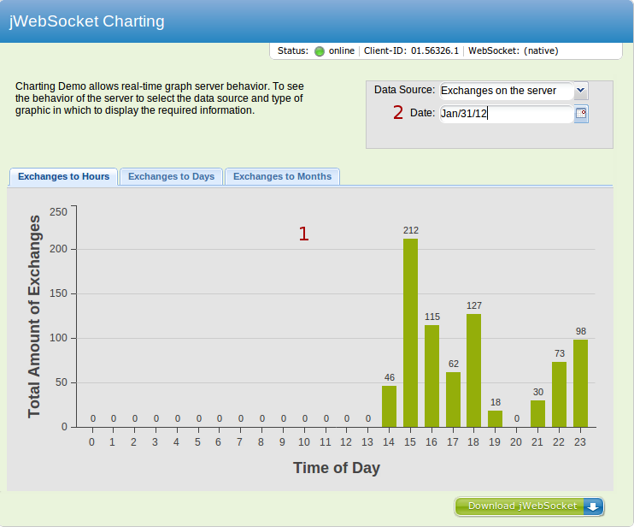

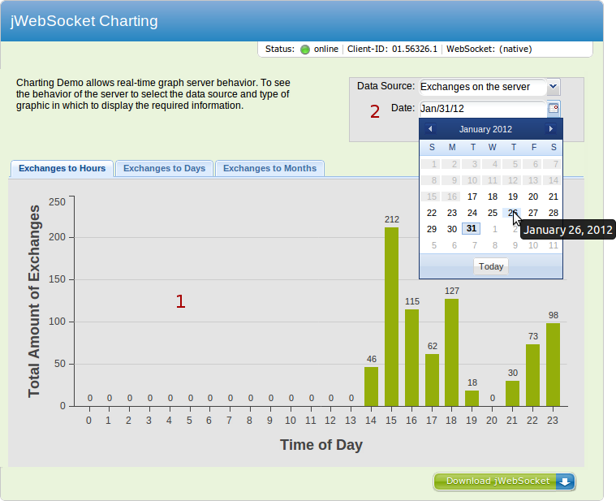

1----- Area where plotted the exchanges of the server at configurable intervals, specifically the exchange by the hour.
2----- Area where there is a calendar to select the day you want to see the server behavior.
------ Download the framework jWebScocket.

Graph Number of exchanges to the server per day: access to the combobox option which allows to represent trade for days made ​​to the server and to select a desired month to see the behavior of that month.

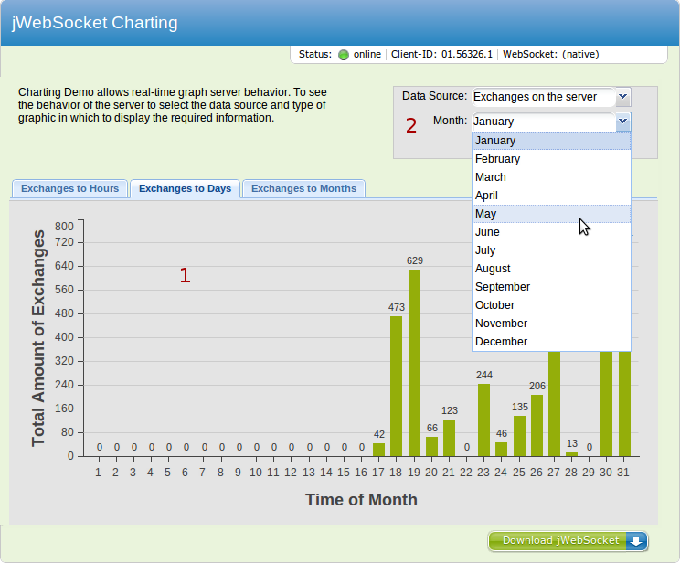
1----- Area where plotted the exchanges of the server at configurable intervals, specifically trade for days.
2----- Area where there is a combobox to select the month you want to see the server behavior.
------ Download the framework jWebScocket.
Graph Number of exchanges to the server per month: access to the combobox option which allows representing exchanges per month made ​​to the server and selects a desired year to view the behavior of that year.

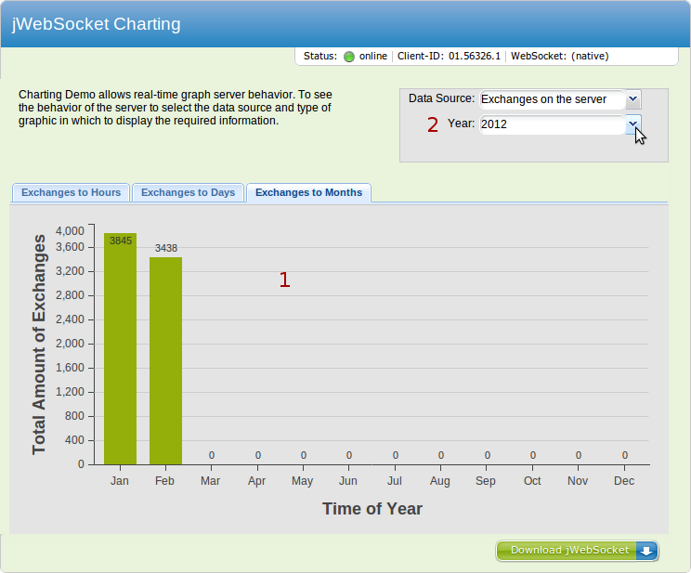

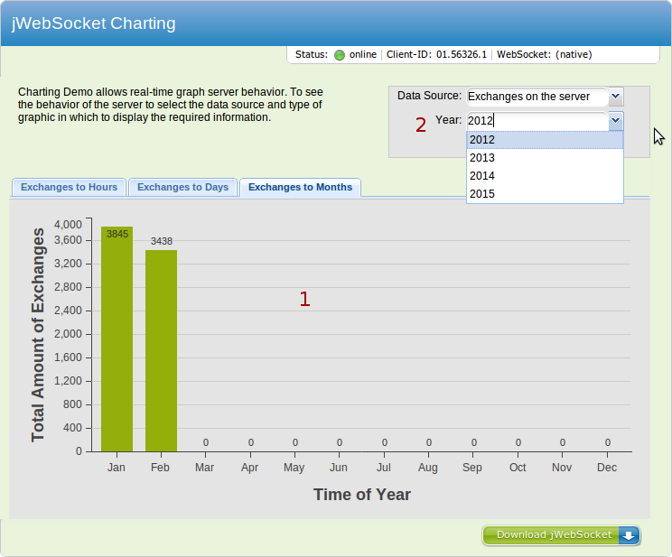

1----- Area where plotted the exchanges of the server at configurable intervals, specifically exchanges per year.
2----- Area where there is a combobox to select the year you want to see the behavior of the server.
------ Download the framework jWebScocket.

Graph Number of users online: access to the combobox option which allows representing the number of users connected.
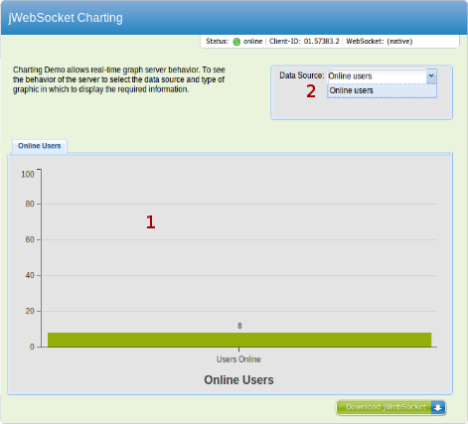

1----- Area where plotted the number of users connected to the application.
2----- Area where you select the items you want to graph.
------ Download the framework jWebScocket.

- Configurations of the solution
This application does not perform configurations.

11. Rules of the solution
R1: If the user selects in the calendar a day in which no server requests have occurred in the feature "Graph Number of exchanges to the server per hour", the system issues an error message and doesn’t continue with the normal flow. Solution: The user must select the correct date for achieving full flow functionality "Graph Number of exchanges to the server per month."

R2: If the user selects the combobox one month in which no server requests have occurred in any of the days of that month, with the functionality "Graph Number of exchanges to the server per day", the system issues an error message and doesn’t continue with the normal flow. Solution: The user must select the correct month to achieve full functionality flow "Graph Number of exchanges to the server per day."

R3: If the user selects the combobox a year in which no server requests have occurred in any of the months of that year, with the functionality "Graph Number of exchanges to the server per month", the system issues an error message and doesn’t continue with the normal flow. Solution: The user must select the correct month to achieve full functionality flow "Graph Number of exchanges to the server per month."

